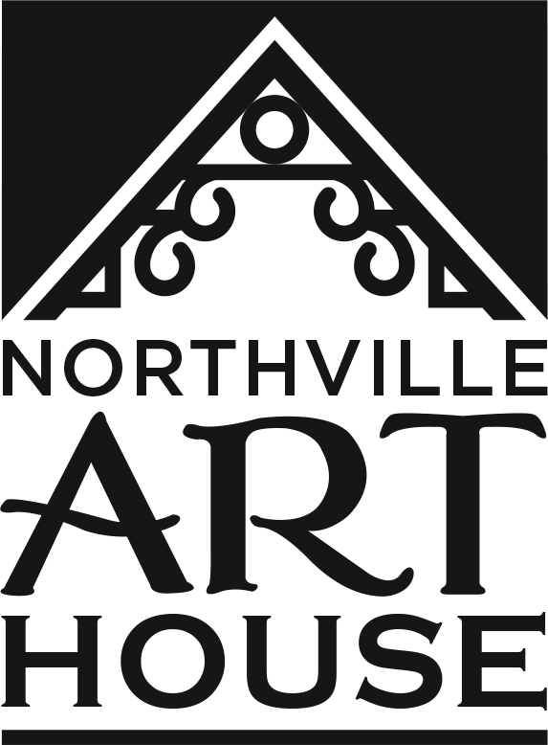
Northville Art House INC
COVID-19 Liability Volunteer Waiver
Date _________________ Program _____________________________________________
Student Name ______________________________________________________________
Parent Name ______________________________________________________________
Phone Number _____________________________________________________________
____I acknowledge the contagious nature of the Coronavirus/COVID-19 and that the CDC and many other public health authorities still recommend practicing social distancing.
I further acknowledge that NORTHVILLE ART HOUSE INC has put in place preventative measures to reduce the spread of the Coronavirus/COVID-19.
Our instructors and staff will…
- Clean/Disinfect frequently touched surfaces thoroughly and at regular intervals.
- Wash/Sanitize our hands before and after each class or program.
- Wear our masks at all times.
- Maintain a safe distance at all times.
- Accommodate a limited number of individuals in each class or program to ensure physical distancing.
- Schedule programs so as to allow time for cleaning/disinfecting surfaces and allow individuals to finish and leave the premises before the next group of individuals arrive.
- Provide sanitizers in the NORTHVILLE ART HOUSE INC area and other locations within the premises.
I further acknowledge that NORTHVILLE ART HOUSE INC cannot guarantee that I will not become infected with the Coronavirus/Covid-19. I understand that the risk of becoming exposed to and/or infected by the Coronavirus/COVID-19 may result from the actions, omissions, or negligence of myself and others, including, but not limited to, NORTHVILLE ART HOUSE INC staff, NORTHVILLE ART HOUSE INC INSTRUCTORS, NORTHVILLE ART HOUSE INC VOLUNTEERS and STUDENTS and their families.
I am voluntarily offering my time at NORTHVILLE ART HOUSE INC and acknowledge that I am increasing my risk to exposure to the Coronavirus/COVID-19. I acknowledge that I must comply with all set procedures to reduce the spread while at the NORTHVILLE ART HOUSE INC area and other locations within the premises.
I attest that:
* I am not experiencing any symptom of illness such as cough, shortness of breath or difficulty breathing, fever, chills, repeated shaking with chills, muscle pain, headache, sore throat, or new loss of taste or smell. _______(Initial)
* I have not traveled internationally within the last 14 days. _______(Initial)
* I have not traveled to a highly impacted area within the United States of America in the last 14 days. _______(Initial)
* I do not believe I have been exposed to someone with a suspected and/or confirmed case of the Coronavirus/COVID-19. _______(Initial)
* I have not been diagnosed with Coronavirus/Covid-19 and not yet cleared as non-contagious by state or local public health authorities. _______(Initial)
* I am following all CDC recommended guidelines as much as possible and limiting my exposure to the Coronavirus/COVID-19. _______(Initial)
We are requesting that each of our volunteers, please…
- Wear a face mask at all times within the building.
- Maintain a safe distance from others at all times.
- Use the hand sanitizer before entering and while exiting the building.
- Carry their own bottle or cup for drinking water.
I hereby release and agree to hold NORTHVILLE ART HOUSE INC harmless from, and waive on behalf of myself, my heirs, and any personal representatives any and all causes of action, claims, demands, damages, costs, expenses and compensation for damage or loss to myself and/or property that may be caused by any act, or failure to act of the NORTHVILLE ART HOUSE INC, or that may otherwise arise in any way in connection with any instruction received from NORTHVILLE ART HOUSE INC. I understand that this release discharges NORTHVILLE ART HOUSE INC from any liability or claim that I, my heirs, or any personal representatives may have against the NORTHVILLE ART HOUSE INC with respect to any bodily injury, illness, death, medical treatment, or property damage that may arise from, or in connection to, any instruction received from NORTHVILLE ART HOUSE INC. This liability waiver and release extends to the NORTHVILLE ART HOUSE INC together with all owners, partners, and employees.

Signature Date

