Roselyn (Rose) Palazzolo Rhodes

Biography
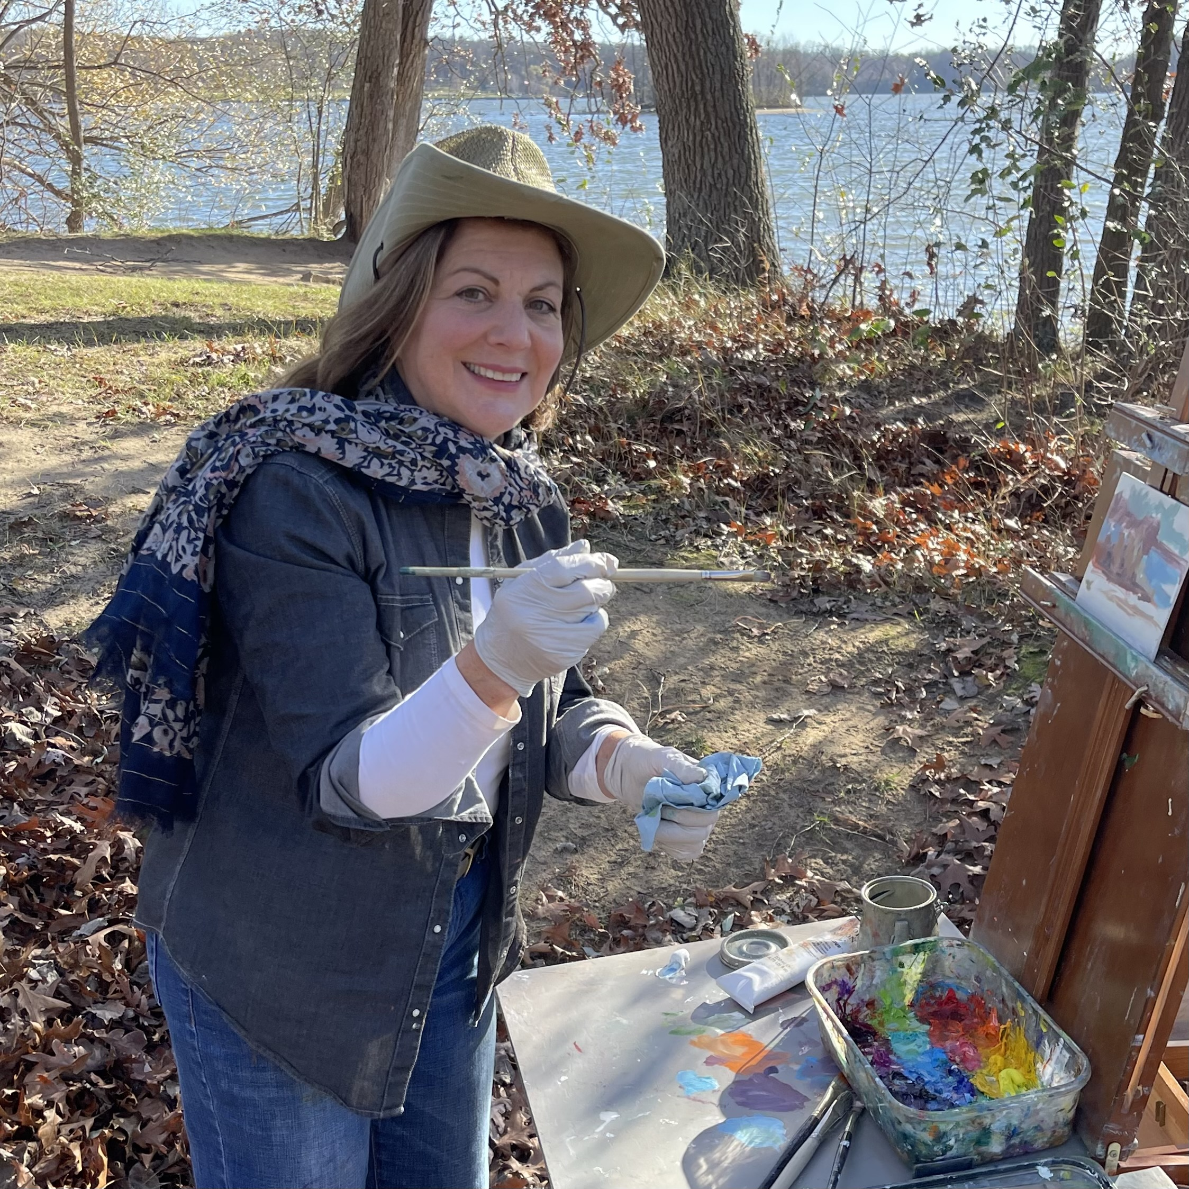
Rose has a BFA in Graphic Design and Fine Arts from the University of Michigan and has worked as a Graphic Designer, Art Director, Art Teacher and commissioned Artist.

Rose teaches fine art classes and private lessons to children, teens and adults. She currently teaches at the Helm and Northville Art Center. She taught for fourteen years in the Grosse Pointe area. A number of her students have received gold key awards, and gone on to successful art careers. She is a member of the Detroit Society of Women Painters and Sculptors.

She is always continuing her education and exploration of oil and watercolor painting thru classes at the Center for Creative Studies, Birmingham Bloomfield Art Center various workshops and with Mary’s studio painters.
The impressionistic to abstract quality of her work is loose, spontaneous and full of expressive color. Her brush strokes evoke an energy that can visually transmit the emotional experience in her paintings.

Rose’s body of work includes impressionistic plein airs, studio landscapes and large abstracts, figurative work from life and adored pets from photos. She does commissions privately or with a designer.
Her work can be seen at galleries and exhibits including Posterity Gallery (Grosse Pointe), Oakwood Hospital, Michigan Design Center, Birmingham Bloomfield Art Center, Detroit Artists Market, Anton Art Center (Mt Clemens), The Great Frame Up, the Okulksi Theater(Grosse Pointe Park), The Art of Custom Framing (Troy), St Joseph Mercy Hospital (Ypsilanti), St. Joseph Hospital, and the Kayrod Gallery.(Detroit)
Artist's Statement
My paintings are a tapestry of colors and forms that together create moods I sense, almost more than see. The movement of the water or breezes blowing around and through me gets visualized through the process of plein-air painting, and then re-imagined in the studio through intuition and experience.

My artistic experience is also defined by change. Change in my process, in my personal visual direction and often in the subjects I choose as well. Change, I feel, is important for growth because without these new challenges, an artist’s best work will always be behind them.

Web: www.artwithrose.com
Email: rose@artwithrose.com
Instagram.com: /artwithrose
Phone: 313-445-6283

